BETH – EL BACKGROUND

Beth-El was started in 1993, the Holy Spirit impressed upon Bishop Johnson that it was a good time to start a fellowship to deal with the increasing number of pastors and churches, both denominational and independent, that were looking to us (The House of the Lord®) for mentoring, teaching, guidance, support, and acccountability.
The secondary burden and vision, was to be a leadership training resource center for the Church community in the region and beyond. It is out of this impression, burden, and vision that the Beth-El Fellowship of Visionary Churches (BFVC) was organized.
What better way to fulfill this vision than by organizing a fellowship to mentor, teach, and hold accountable the pastors and churches who are looking to us for guidance and support? The name Beth-El, was chosen because of its biblical significance. The name "Beth-El" means "The House of God." Therefore, the "Beth-El" Fellowship of Visionary Churches will be a fellowship of "Houses of God." (Excerpt by Bishop Johnson from a 1993 Vision Statement)
The word "fellowship" means: 1. communion: a sharing of common interests, goals, experiences, or views 2. society: a group of people who share common interests, goals, experiences, or views 3. companionship: companionship or friendly association 4. similarity: membership in a group, or the sharing of characteristics with others.

Although the BFVC was initially organized to support independent churches, we have quickly realized that churches with denomination affiliation may also need some type of support network to undergird them in their mission of helping to usher in the final manifestation of the Kingdom of God. The BFVC is committed to assisting pastors, their leadership team and churches in important areas that many seminaries, Bible colleges and Bible institutes, as well as denominational conferences seem to vastly ignore. As a result, many pastors admit (if only secretly) to feeling inadequate, unprepared and/or alone in their call to the ministry.
Pastors and churches don't have to settle for being mediocre or even good, but should pursue greatness in the Kingdom of God. In this season, the Holy Spirit is directing Beth-El to seek His desire even more and expand the vision, and invite you and your church to be a part of this Fellowship and the next move of God.

Beth -El Fellowship of Visionary Churches
Benefits Package for Churches to Active Status

- Apostolic Covering by Presiding Bishop Flanvis Josephus Johnson

- Access to Bishop Johnson’s resources, sermons and notes

- Free church consultations

- Free mediation services

- Yearly conferences and workshops designed to aid in church development

- Access to continued education (LOGOS/Ashland University)

- Monthly Video Conference facilitated by Bishop Johnson

- Assistance with Church Governance

- Ordination Services

- Ministerial Training ***when offered**

- Leadership Training ***when offered***

- Access to services offered by the executive board

- Church Visits (evaluations upon request)

COMMITMENT AGREEMENT

I ______________________________ Pastor of _____________________________________,
Pastor’s Name Church Name

commit to Beth-El the amount of $________ for the year. The commitment will be paid to Beth- EL.

______ Monthly _______ Semi-Quarterly

_______ Quarterly _______ Annually

BETH-EL BOARD MEMBERS CONTACT

Apostle Carrie L. Brown (President) carrieloubrown@yahoo.com
Pastor Daren Drake (Vice-President) darenb@thotl.org
Min. Antonio Jackson (Treasurer) ministerantonio@sbcglobal.net
Min. Alta Wilcox (Secretary) altajwilcox@gmail.com
Pastor Joseph Walker(Board Member) pastorwalker@restoreme.org

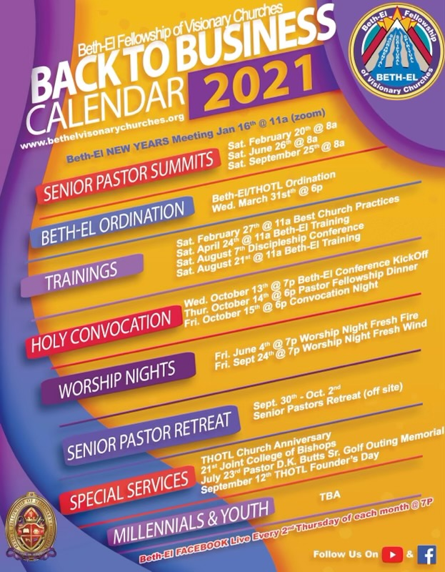

LOGOS BIBLE INSTITUTE

Pre-registration February 1, 2021
Orientation March 1, 2021
First Day of Class March 8, 2021

Registration can be done online at www.lbi-thotl.org
For more information or help with class registration please contact Rev. Dr. Annie Grace Clark – Director at 216-409-6466 or anniecla@windstream.net

